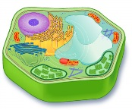
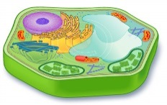
Cell structure - an overview

Cells are composed of many different organelles that serve separate purposes within the cell.
The Cell Membrane separates the ___________ of the cell from it’s ___________.
The Cytosol or Cytoplasm is a _____________________ found in the cell. The organelles are suspended in the cytosol.
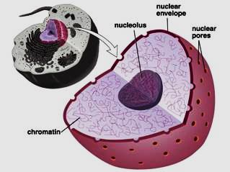
The Nucleus is the ________________. The nucleus __________ or ___________________. DNA dictates ____________________________ and how it is going to do it (through controlling the productionof proteins).
The Nucleolus is a structure where _______________ are made.
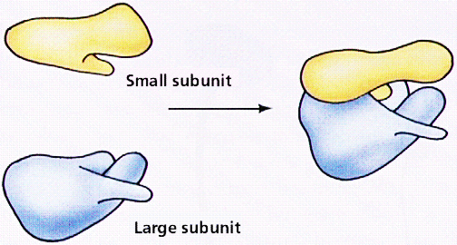
Ribosomes make ___________ from amino ___________.
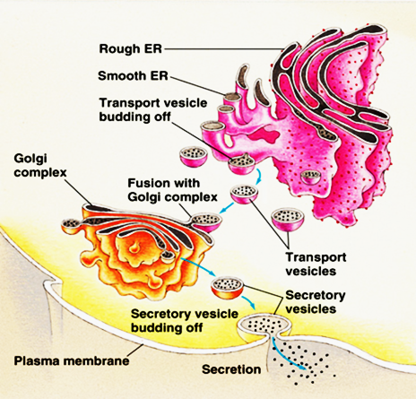
Smooth Endoplasmic Reticulum is where the transport nutrients and _______________.
Rough Endoplasmic Reticulum has ___________ attached to it.
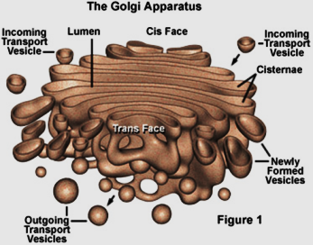
The Golgi Apparatus sometimes called the _________ ___________. It is responsible for the ___________ of proteins and the ______________ of lipids and _________________ to them.
The Vacuole are ___________ ___________ that store ___________. Vacuoles are especially important in plant cells as they provide internal support to cell rigidity. When a vacuole shrinks through water loss you can see the leaves of the plant wilt.
Lysosomes are the ____________ ___________. They take in ____________ or _______________ cell parts. Lysomes contain ______________ which breakdown this ________________________.
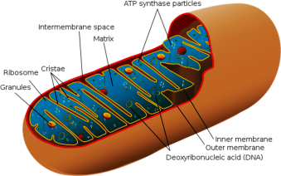
Mitochondria are the ______________ of the cell. During ________________ the mitochondria make ATP molecules which provide all the ____________ the cell needs. Cells which need more ___________ have more __________________.
The Cytoskeleton holds the threadlike ________________ and _____________ which help hold the cell together.
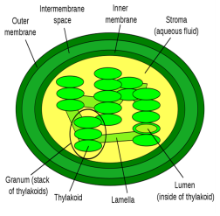
Chloroplasts is where ______________ occurs. This is where carbon dioxide and water are converted to glusose and oxygen. Chloroplasts are green because they contain ___________________.

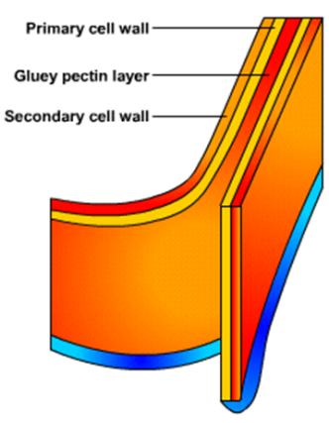
A cell wall is in plant cells. A cell wall is outside the cell ________________ and it shapes, __________, and ____________ the plant cell. It is made of cellulose, a tough protein.

